Michael Shalaby
CSD325 - Advanced Python
Bellevue University
Assignment 9.2

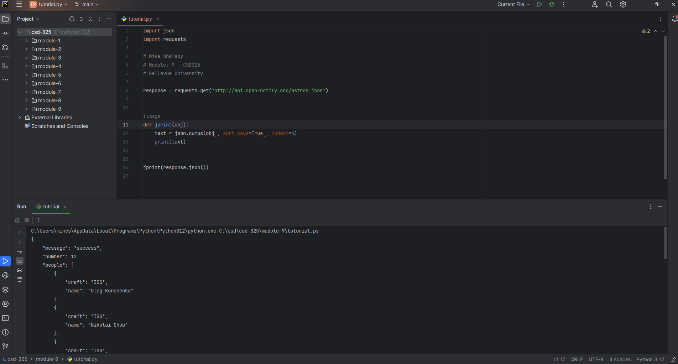
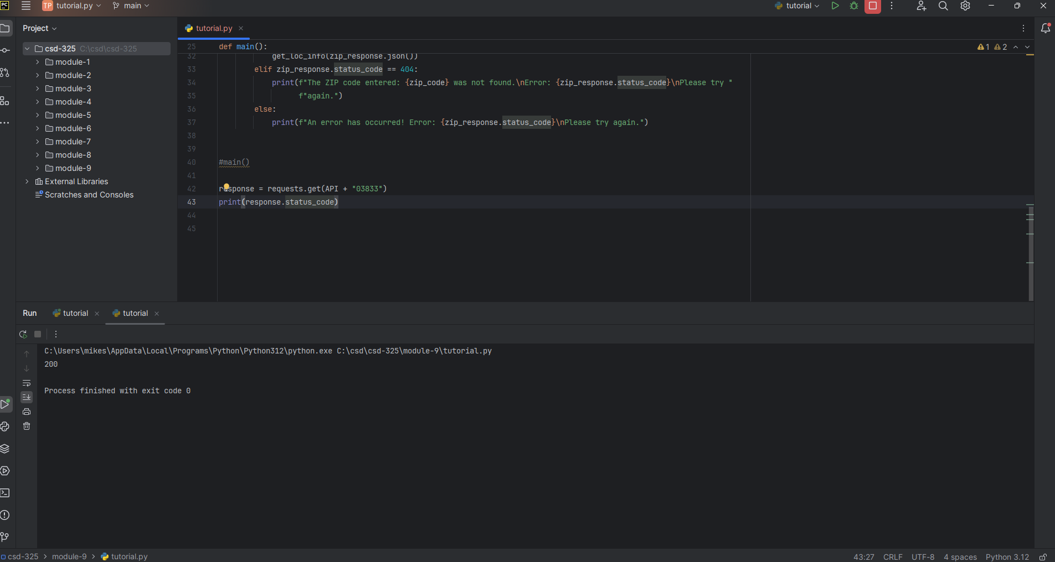

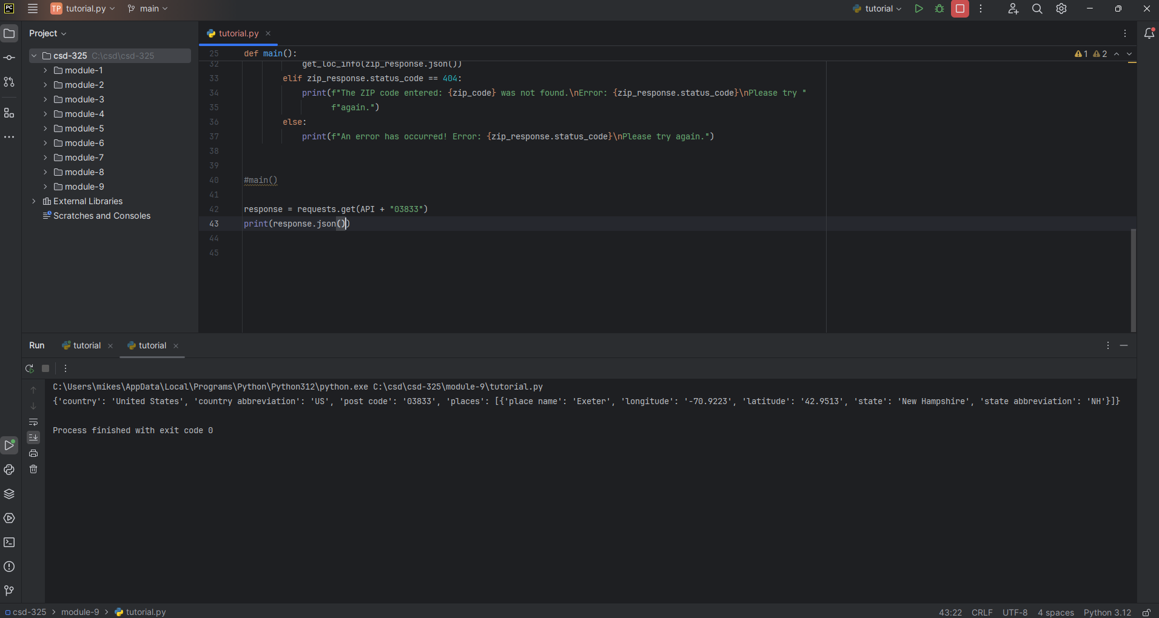

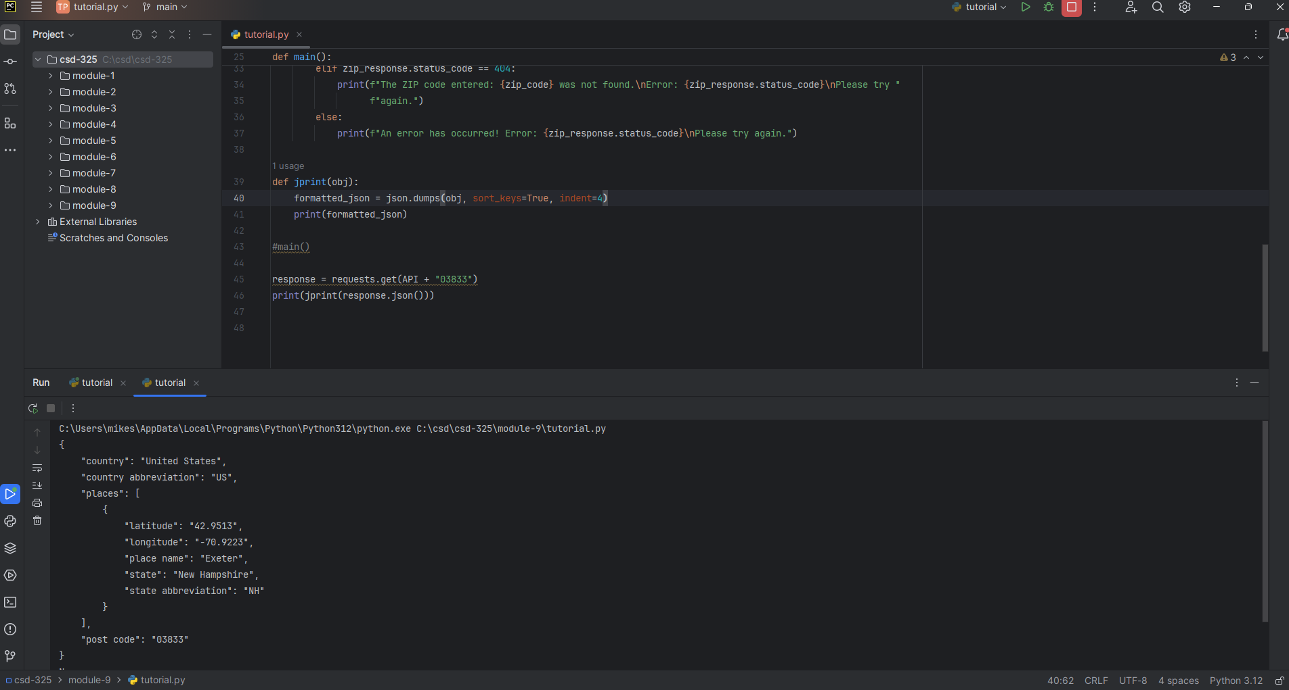
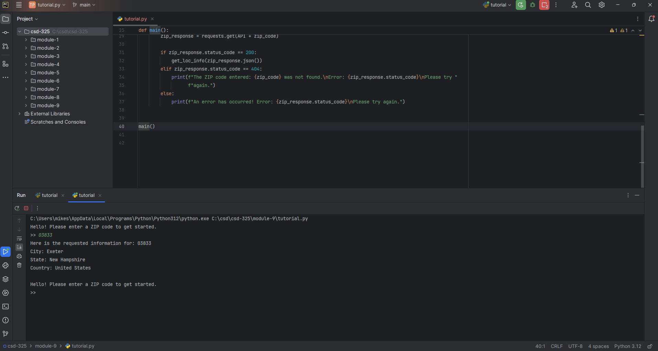

The API I chose for this assignment is the Zippopotam.us API: https://zippopotam.us/. It returns information on a given ZIP code. In the program, a user enters a ZIP code it will return the information in a formatted way.

